**FISH 458/558 - Fish Population Dynamics**

**LAB ASSIGNMENT #9 (Catch curves and mortality)**

*Complete and return your assignment (via Canvas) in the form of a Word document by the due date (with any answers and figures requested and with the R script copied in).*

*Guidelines:*

* *Include the course, lab number, and date at the top of the document. Do NOT include your name.*
* *Number and label the questions and answers clearly! (We should easily be able to find your answers!)*
* *Include all of the requested output (e.g., values, data tables, and plots), not just the code for them. (We will not copy your code into R to see if it works).*
* *Include informative captions for figures and tables. See research articles for examples.*
* *Submit a Word document unless directed otherwise (no r files or pdfs please).*
* *Include all your code used for the problems.*
* *Answer ALL questions using complete sentences that are clear and informative.*

**ALL STUDENTS (458 & 558) (24 pts)**

1. Describe the concept of catch curves and how they make sense. Include the assumptions of the method as well as a discussion of multiple situations where we might not expect those assumptions to be valid. (4 pts)
2. Select one of the catch-at-age data sets in the “**FSAdata**” package, and use catch curve methods to estimate the total instantaneous mortality rate (Z) for that population. For this, make sure the “FSA” and “FSAdata” packages are installed. Then, to see sample data sets you can run: **help.search("Catch curve",package=c("FSAdata","FSA"))** to see a list of available data sets. To load and activate the dataset, use **data(DATASET_NAME)**, as demonstrated in lab.
   1. Identify what dataset you used and what the data are from (species, location, study, etc., as available). (1 pt)
   2. Provide a table of Z estimates (with 95% Confidence intervals) using the basic catch curve regression and the Chapman-Robson method. (2 pts)
   3. Present a plot of log(catch) vs. age for your data set, with a fit of the basic catch curve regression. (3 pts)
3. For this question, the goal is for you to develop multiple estimates of instantaneous natural mortality (M) for a species of interest to you. Select a species, search for it on **fishbase.org**, and then click on the “Growth” link under the “More information” section for that species (see **Figure 1**). Choose a species that has estimates of life history parameters from at least 3 different studies (i.e., three different rows) when you look at the “Growth” information (see **Figure 2**).
   1. State the species you selected and give a brief description of it (e.g., species distribution, life history characteristics). Provide the estimates for Linf, K, and Temperature for your selected species (note, you may not have estimates for all 3 of these, but you should have at least two), and define what those parameters are. Also, include a screen shot of the “Growth Parameters” table (e.g., see **Figure 2**). (2 pts) A screenshot of a computer

      Description automatically generated
   2. Using the life history information available for the species from only 1 study (i.e., data from one row in Figure 2), generate a minimum of 5 different estimates of instantaneous natural mortality (M) using different empirical methods (you may use as many as you’d like). Use the **metaM()** function in the FSA package. Look at the “Details” section of the **metaM()** help menu to see which methods can be used with the life history parameters you obtained. Provide a table (with caption) of the different M estimates you generated. Create a column in your table that re-expresses the instantaneous mortality rate M as an annual rate (v), where v=the proportion of fish dying from natural causes in a year, calculated as: **v=1-e-M**. (3 pts)
   3. Calculate the mean, standard deviation, minimum, and maximum of your M and v estimates. The **summary()** function would be handy here. Describe the patterns and variability you see in M and v. (2 pts)
   4. Select one of the empirical methods and now generate different M estimates using the different life history parameters from the different studies. As in part c, describe the patterns and variability you see. For example, the “PaulyLNoT” method requires K and Linf, and we see several estimates of these parameters in Figure 2 below. (2 pts)
      1. Note, if using Linf as a parameter, only use estimates from **Figure 2** that have: Length Type = TL (total length), and if sex information is available, try to be consistent with the studies you use (e.g., generate estimates for Males or Females only).
   5. Based on your answers to c and d, discuss and compare the sources of uncertainty and variability that would affect any empirical estimates of M. (2 pts)
   6. Provide a general description of how and why these empirical estimates of M make sense biologically. For example, how and why would M for fishes be related to K, Linf, or Temperature? (2 pts)
4. Answer these questions (1 pt):
   1. How many hours did you spend on this assignment as a whole? (**40 min so far) + 4 to 7 + 1 + 1 + 30min**
   2. Did you work with anyone else or at least consult with someone? Who?
   3. Were there any particular things you struggled with in this lab and how did you overcome them?

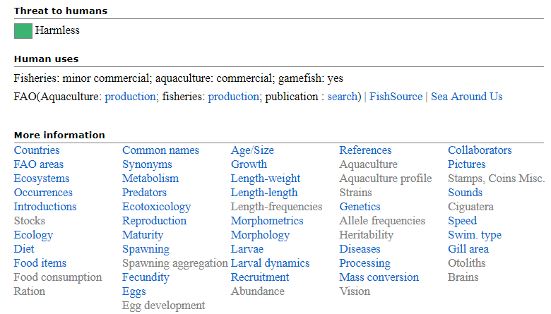

**Figure 1.** Screen shot for part of the Striped Bass (*Morone saxatilis*) main page obtained from fishbase.org. Clicking on the “Growth” button under “More information” will open up a table of life history parameters for this species.

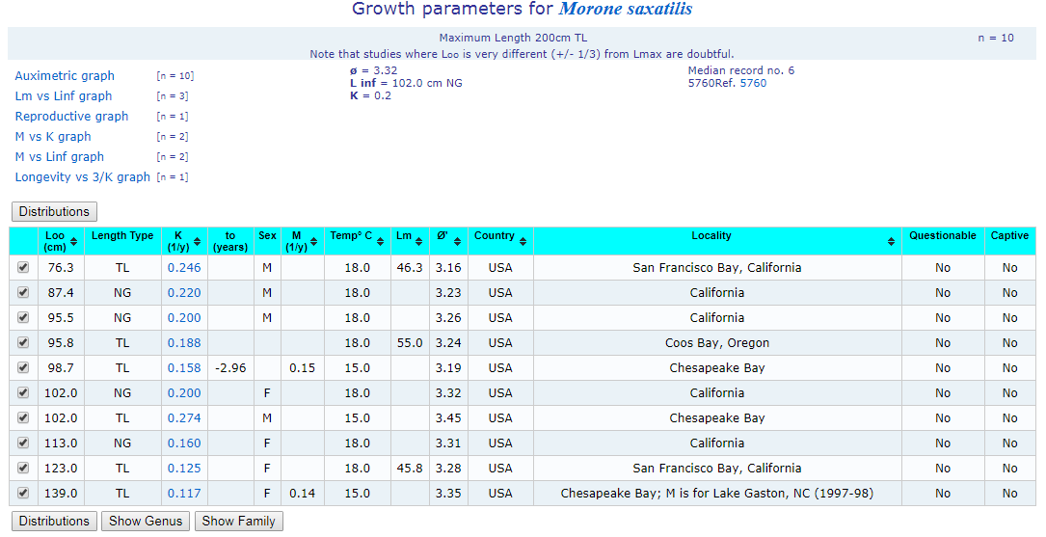

**Figure 2.** Screen shot of the growth parameter table for Striped Bass (*Morone saxatilis*) obtained from fishbase.org. Each row represents life history parameter estimates from a different study. The life history parameters in this table can be used to estimate natural mortality rate (M) for fishes.

**558 STUDENTS**

Please read the feedback provided on your project synopsis. Spend some time working on your research project. Write a 2-4 sentence update on what you worked on.